SIMATS ENGINEERING
ASSESSMENT TOOL 3

COURSE NAME: Artificial Intelligence
COURSE CODE: CSA1704

COURSE OUTCOME COVERED

CO3: Analyze knowledge representation and reasoning using propositional logic, FOL, inference, resolution, chaining methods, knowledge representation to perform logical reasoning for drawing valid conclusions and decision making. (BL4)

Assessment Tool Weightage: 20%

Time Duration: 1 Hour
QUESTIONS: 5 Total Marks:30

Annexure A

Resolution Algorithm Implementation

Code of Conduct:

I Sadhana V(192565042)(Name / Reg No) certify that this submission is my original work and that I have adhered to the guidelines specified for this assessment.
I understand that any violation of academic integrity rules will result in disciplinary action.

Signature of the student:

Annexure A

Resolution Algorithm Implementation

Question 1 – Rain and Wet Ground
Problem
A knowledge base contains information that it is raining and that if it rains, the ground becomes wet. The objective is to prove that the ground is wet using the Resolution Algorithm by converting the statements into propositional logic, CNF, and resolving the negated goal.
Solution
- Propositional Logic: Let R = It is raining and W = The ground is wet.
- Premise 1: If it rains, then the ground becomes wet: R → W.
- Premise 2: It is raining: R.
- Goal: W.
- CNF Conversion: R → W becomes ¬R ∨ W.
- Negated Goal: ¬W.
- Resolution: Resolve ¬R ∨ W with R to obtain W.
- Final Resolution: Resolve W with ¬W to obtain the Empty Clause □.
- Conclusion: Since the Empty Clause is obtained, the goal is proved.
Python Code
# Resolution Algorithm - Rain and Wet Ground

clauses = [
["not_R", "W"], # R -> W
["R"], # It is raining
["not_W"] # Negated goal
]

# Resolve (not_R or W) with R
print("Clause 1: not_R OR W")
print("Clause 2: R")
print("Resolvent: W")

# Resolve W with not_W
print("Clause 3: not_W")
print("Resolvent: Empty Clause")

print("Goal Proved: The ground is wet.")
Output
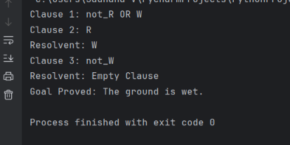
Report
The Resolution Algorithm proves that the ground is wet because the premises produce W, while the negated goal produces ¬W. Resolving W and ¬W produces the Empty Clause □, confirming that the goal is true.

Question 2 – Student Assignment Submission
Problem
A knowledge base contains information that if a student submits an assignment, the student receives internal marks. Rahul has submitted the assignment. The objective is to prove that Rahul receives internal marks using the Resolution Algorithm.
Solution
- Propositional Logic: Let S = Rahul submitted the assignment and M = Rahul receives internal marks.
- Premise 1: If Rahul submits the assignment, then Rahul receives internal marks: S → M.
- Premise 2: Rahul submitted the assignment: S.
- Goal: M.
- CNF Conversion: S → M becomes ¬S ∨ M.
- Negated Goal: ¬M.
- Resolution: Resolve ¬S ∨ M with S to obtain M.
- Final Resolution: Resolve M with ¬M to obtain the Empty Clause □.
- Conclusion: Since the Empty Clause is obtained, Rahul receives internal marks is proved.
Python Code
# Resolution Algorithm - Student Assignment

clauses = [
["not_S", "M"], # S -> M
["S"], # Rahul submitted assignment
["not_M"] # Negated goal
]

print("Clause 1: not_S OR M")
print("Clause 2: S")
print("Resolvent: M")

print("Clause 3: not_M")
print("Resolvent: Empty Clause")

print("Goal Proved: Rahul receives internal marks.")
Output
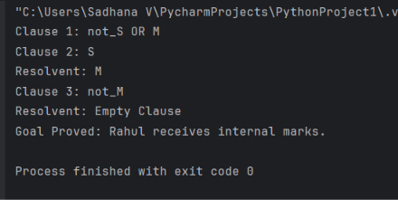
Report
The Resolution Algorithm proves that Rahul receives internal marks because Rahul submitted the assignment and the rule states that submission results in internal marks. Resolving the goal with its negation produces the Empty Clause □, proving the goal.

Question 3 – Library Membership
Problem
A knowledge base contains information that if a person is a library member, the person can borrow books. Priya is a library member. The objective is to prove that Priya can borrow books using the Resolution Algorithm.
Solution
- Propositional Logic: Let L = Priya is a library member and B = Priya can borrow books.
- Premise 1: If Priya is a library member, then Priya can borrow books: L → B.
- Premise 2: Priya is a library member: L.
- Goal: B.
- CNF Conversion: L → B becomes ¬L ∨ B.
- Negated Goal: ¬B.
- Resolution: Resolve ¬L ∨ B with L to obtain B.
- Final Resolution: Resolve B with ¬B to obtain the Empty Clause □.
- Conclusion: Since the Empty Clause is obtained, Priya can borrow books is proved.
Python Code
# Resolution Algorithm - Library Membership

clauses = [
["not_L", "B"], # L -> B
["L"], # Priya is a library member
["not_B"] # Negated goal
]

print("Clause 1: not_L OR B")
print("Clause 2: L")
print("Resolvent: B")

print("Clause 3: not_B")
print("Resolvent: Empty Clause")

print("Goal Proved: Priya can borrow books.")
Output
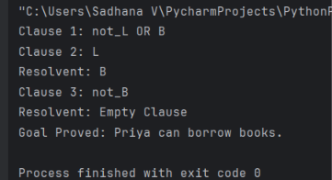
Report
The Resolution Algorithm proves that Priya can borrow books because she is a library member and the given rule states that library members can borrow books. The contradiction between B and ¬B produces the Empty Clause □, proving the goal.

Question 4 – Placement Eligibility
Problem
A knowledge base contains information that if a student clears the aptitude test, the student is eligible for placement. Arun cleared the aptitude test. The objective is to prove that Arun is eligible for placement using the Resolution Algorithm.
Solution
- Propositional Logic: Let A = Arun cleared the aptitude test and E = Arun is eligible for placement.
- Premise 1: If Arun clears the aptitude test, then Arun is eligible for placement: A → E.
- Premise 2: Arun cleared the aptitude test: A.
- Goal: E.
- CNF Conversion: A → E becomes ¬A ∨ E.
- Negated Goal: ¬E.
- Resolution: Resolve ¬A ∨ E with A to obtain E.
- Final Resolution: Resolve E with ¬E to obtain the Empty Clause □.
- Conclusion: Since the Empty Clause is obtained, Arun is eligible for placement is proved.
Python Code
# Resolution Algorithm - Placement Eligibility

clauses = [
["not_A", "E"], # A -> E
["A"], # Arun cleared aptitude test
["not_E"] # Negated goal
]

print("Clause 1: not_A OR E")
print("Clause 2: A")
print("Resolvent: E")

print("Clause 3: not_E")
print("Resolvent: Empty Clause")

print("Goal Proved: Arun is eligible for placement.")
Output
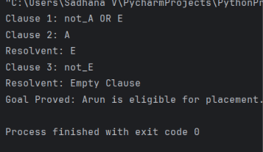
Report
The Resolution Algorithm proves that Arun is eligible for placement because he cleared the aptitude test and the given rule states that clearing the test makes a student eligible for placement. Resolving E with ¬E produces the Empty Clause □, proving the goal.

Question 5 – Access Control System
Problem
An access control system authenticates a user when the correct password is entered. An authenticated user is then granted access. The user entered the correct password. The objective is to prove that the user is granted access using the Resolution Algorithm.
Solution
- Propositional Logic: Let P = The user entered the correct password, A = The user is authenticated, and G = The user is granted access.
- Premise 1: If the user enters the correct password, then the user is authenticated: P → A.
- Premise 2: If the user is authenticated, then the user is granted access: A → G.
- Premise 3: The user entered the correct password: P.
- Goal: G.
- CNF Conversion: P → A becomes ¬P ∨ A.
- CNF Conversion: A → G becomes ¬A ∨ G.
- Negated Goal: ¬G.
- Resolution Step 1: Resolve ¬P ∨ A with P to obtain A.
- Resolution Step 2: Resolve ¬A ∨ G with A to obtain G.
- Resolution Step 3: Resolve G with ¬G to obtain the Empty Clause □.
- Conclusion: Since the Empty Clause is obtained, the user is granted access is proved.
Python Code
# Resolution Algorithm - Access Control System

clauses = [
["not_P", "A"], # P -> A
["not_A", "G"], # A -> G
["P"], # Correct password
["not_G"] # Negated goal
]

print("Clause 1: not_P OR A")
print("Clause 2: P")
print("Resolvent: A")

print("Clause 3: not_A OR G")
print("Clause 4: A")
print("Resolvent: G")

print("Clause 5: not_G")
print("Resolvent: Empty Clause")

print("Goal Proved: The user is granted access.")
Output
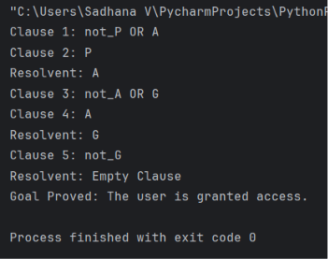
Report
The Resolution Algorithm proves that the user is granted access because the correct password leads to authentication, and authentication leads to access. The final resolution between G and ¬G produces the Empty Clause □, confirming that the goal is proved.

